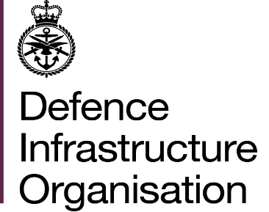

Damage and Deficiencies Charges

This document outlines details about how charges will be recovered. It also provides information about how to dispute charges if you consider that you are not responsible for the damage or that the damage is a result of fair wear and tear. Please read all the information contained in this document and note that any dispute must be submitted within 30 days of the notification of charges email.

Damage and Deficiencies – Recovery Action

Damage and Deficiencies charges have been raised at your move out appointment, or during your occupancy, of Service Family Accommodation (SFA)/Substitute Service Family Accommodation (SSFA).

Recovery action will be initiated 30 days after the date of the notification email and may be recovered via JPA or via an invoice. Any dispute of the charges must be submitted within this 30-day period. Please refer to the relevant section below for information detailing how to submit a dispute.

Recovery via JPA

Recovery will be initially attempted via JPA. Charges are recovered at a rate of no more than 4 days gross pay per month. Further information on the recovery period can be found in JSP 754, Pay and Reward Payments, Part 2 (Regulations), Paragraph 63.3. For enquiries about arranging payment plans via JPA, personnel should contact either their unit HR or the JPAC enquiries centre at the email address: DBS-JPAC@dbspv.mod.uk

If recovery through JPA is not possible, for example following discharge from the service, an invoice will be raised.

Recovery via invoice

Where JPA cannot be used to recover the charges, an invoice will be created and sent by Defence Business Services (DBS). Upon receipt of the invoice, you should contact Defence Business Services to make payment. Payment methods will be detailed on the invoice and payment plans can be directly discussed with DBS using the contact details on the invoice.

Submission of a dispute

If you consider that you are not responsible for the damage or that the damage is the result of fair wear and tear, you can dispute the charges raised.

The Stage 1 Disputed Charges form is available on the Pinnacle Service Families website here: Dispute Charges – Fill in form

Stage 1 Disputes will only be accepted using this form, clearly stating reasons for each disputed charge and any efforts made to resolve the dispute at the move out. Any supporting evidence, such as photographs, should be sent to Dispute.Charges@pinnacleservicefamilies.co.uk referencing your Move Out date and address. The completed S1 Dispute form must be submitted to Pinnacle within 30 days of the notification of charges email.

Further information

For further information on this process please refer to 2026DIN01-053: "Charges for Damage and Deficiencies for Service Family Accommodation (SFA) and Substitute SFA (SSFA) for Move Outs from 1st May 2026"
2026DIN01-053-Charges for Damage and Deficiencies for Service Family Accommodation (SFA) and Substitute SFA (SSFA) for Move Outs from 1st May 2026.docx

Housing Delivery Services
DIO Accommodation

